**Monitoring Agricultural Runoff into Water Bodies**

Amirtha Vahini1, Mohanapriya 1 and Harini1

1 Vellore Institute of Technology, Chennai

amirthavahini.v2022@vitstudent.ac.in, [mohanapriya.s2022@vitstudent.ac.in](mailto:mohanapriya.s2022@vitstudent.ac.in),

[harini.s2022@vitstudent.ac.in](mailto:harini.s2022@vitstudent.ac.in)

**Abstract.** Monitoring agricultural runoff into water bodies is essential to address the impact of agricultural practices on water quality. This project explores the use of digital image processing techniques to monitor, analyze, and quantify agricultural runoff. The study focuses on detecting suspended sediments, nutrient concentrations, and other pollutants in water bodies using satellite imagery and drone-based sensors. By employing image segmentation, object recognition, and color-based analysis, we develop a system that can detect and track runoff patterns over time. The system's effectiveness lies in its ability to assess water quality in real-time, providing valuable insights for environmental management and policy-making. Additionally, machine learning algorithms are integrated to enhance the accuracy and reliability of runoff detection, allowing for early interventions and improved agricultural practices to mitigate pollution. The outcomes of this project aim to support sustainable agriculture by protecting aquatic ecosystems.

**Keywords:** Agricultural runoff, Water quality monitoring, Digital image processing, Satellite imagery, Drone-based sensors, Image segmentation, Nutrient pollution, Environmental management, Machine learning

1. Introduction

Agricultural runoff is a major contributor to water pollution worldwide, impacting aquatic ecosystems, drinking water sources, and overall environmental health. Runoff from agricultural fields often contains sediments, pesticides, fertilizers, and other chemicals that can enter nearby rivers, lakes, and reservoirs. These pollutants lead to issues such as eutrophication, harmful algal blooms, and biodiversity loss, ultimately disrupting water ecosystems and posing risks to human health. Monitoring agricultural runoff is therefore crucial to understanding and mitigating its effects on water bodies.

Traditional methods for monitoring runoff are labor-intensive, requiring manual water sampling and laboratory testing. While effective, these methods lack the capability for real-time and large-scale monitoring. Advances in digital image processing, remote sensing, and drone technology offer promising alternatives by enabling the analysis of images captured from satellites and drones. These techniques can detect and quantify changes in water quality indicators, such as turbidity, suspended particles, and color variations, associated with agricultural runoff.

This project aims to develop a digital image processing system to monitor agricultural runoff in water bodies. By analyzing images from multiple sources, the system can identify and track runoff patterns, providing timely data for environmental agencies and policymakers. Using image segmentation, pattern recognition, and machine learning algorithms, we aim to automate the detection process and improve the accuracy of runoff assessments. Ultimately, this approach supports sustainable agriculture and environmental protection by providing a scalable, efficient solution for water quality monitoring and pollution prevention.

1. Related Work

Several studies have highlighted the importance of monitoring agricultural runoff and the innovative use of digital image processing and remote sensing to assess water quality in affected water bodies. In recent years, researchers have leveraged satellite imagery, drone technology, and advanced image processing techniques to enhance the efficiency and accuracy of environmental monitoring systems. Below are some relevant works in this area:

**2.1 Satellite Remote Sensing for Water Quality Monitoring:**

Numerous studies have demonstrated the use of satellite-based remote sensing to monitor water quality. For instance, research by Kallio et al. (2011) used satellite imagery to detect suspended particulate matter and chlorophyll concentrations, providing valuable indicators of agricultural runoff. Similarly, Wang et al. (2019) applied Landsat-8 imagery to monitor nutrient concentrations and sediment load in water bodies near agricultural regions, achieving notable success in real-time monitoring capabilities.

**2.2 Drone-Based Image Analysis in Environmental Monitoring:**

The increasing availability of drone technology has also advanced agricultural runoff monitoring. In their study, Villa et al. (2017) demonstrated the use of drones equipped with multispectral sensors to monitor turbidity levels in small to medium water bodies. This method was found to be highly effective in capturing high-resolution images that detect water quality indicators impacted by agricultural runoff. Drones have proven particularly valuable in covering smaller, inaccessible areas, where ground-based monitoring is challenging.

**2.3 Digital Image Processing Techniques for Runoff Detection:**

Image processing techniques, such as segmentation and color analysis, have shown great promise in detecting pollutants and suspended sediments. Sharma et al. (2018) applied a combination of image segmentation and supervised classification to identify runoff patterns in river systems. Using digital image processing to analyze water quality parameters, they achieved improved detection of contaminants like phosphates and nitrates, which are often linked to agricultural practices.

**2.4 Machine Learning Applications in Water Quality Prediction:**

The integration of machine learning techniques into digital image processing for environmental monitoring has gained traction. Singh et al. (2020) used machine learning algorithms, including support vector machines (SVM) and neural networks, to classify water quality indicators from processed satellite images. Their model demonstrated high accuracy in distinguishing between polluted and non-polluted water areas, thereby facilitating better prediction and management of agricultural runoff impacts.

**2.5 Automated Systems for Real-Time Monitoring:**

Automated real-time monitoring systems are increasingly being developed to provide timely data for environmental management. Zhu et al. (2021) introduced an IoT-based monitoring system that integrates satellite and drone images with machine learning algorithms, enabling continuous monitoring of nutrient and sediment runoff. This system provides near real-time updates, empowering policymakers to respond promptly to runoff events and implement corrective measures to protect water quality.

The related works demonstrate a progressive shift from manual, ground-based water quality assessments to sophisticated, automated systems leveraging digital image processing and machine learning. This project builds on these approaches by integrating high-resolution satellite and drone imagery with advanced image processing and machine learning techniques. The goal is to create a scalable, cost-effective system for monitoring agricultural runoff, improving the speed and accuracy of water quality assessments, and supporting environmental sustainability initiatives.

1. Methodology

**3.1 Data Acquisition**

Satellite Imagery: Acquire high-resolution satellite images from sources like Landsat, Sentinel, or commercial providers.

Aerial Photography: Use drones or aircraft to capture detailed images of agricultural fields and adjacent waterbodies.

Ground Truthing: Collect ground-based data to validate and calibrate the remote sensing data.

**3.2 Preprocessing**

Radiometric Correction: Adjust the image data to correct for sensor irregularities and atmospheric interference.

Geometric Correction: Align the images to a common coordinate system using ground control points.

Image Enhancement: Apply techniques such as histogram equalization, contrast stretching, and noise reduction to improve image quality.

**3.3 Feature Extraction**

Vegetation Indices: Calculate indices like NDVI (Normalized Difference Vegetation Index) to differentiate between agricultural fields and other land covers.

Water Indices: Use indices like NDWI (Normalized Difference Water Index) to delineate waterbodies from other surfaces.

Spectral Signature Analysis: Identify unique spectral signatures of various pollutants (e.g., nutrients, sediments) present in runoff.

**3.4 Image Segmentation**

Thresholding: Apply threshold values to separate agricultural fields, waterbodies, and runoff areas.

Clustering: Use clustering algorithms (e.g., K-means, ISODATA) to classify pixels into distinct categories.

Edge Detection: Implement edge detection techniques (e.g., Canny, Sobel) to identify boundaries of runoff flows.

**3.5 Change Detection**

Temporal Analysis: Compare images from different time periods to detect changes in water quality and land use.

Image Differencing: Subtract one image from another to highlight areas of change, particularly in water turbidity and vegetation cover.

Post-Classification Comparison: Classify images from different dates and compare the classifications to identify changes due to runoff.

**3.6 Quantification of Runoff Impact**

Water Quality Indicators: Analyze indicators like turbidity, chlorophyll concentration, and suspended sediments using spectral analysis.

Pollutant Load Estimation: Estimate the concentration of specific pollutants (e.g., nitrogen, phosphorus) using regression models or machine learning techniques.

Runoff Volume Estimation: Calculate the volume of runoff using hydrological models and spatial analysis.

**3.7 Validation and Accuracy Assessment**

Ground Truth Comparison: Validate the detected runoff areas with field data and observations.

Accuracy Metrics: Calculate metrics like confusion matrix, overall accuracy, kappa coefficient, and precision-recall for the classification results.

Cross-Validation: Perform cross-validation using independent datasets to ensure the robustness of the detection methodology.

**3.8 Reporting and Visualization**

Maps and Charts: Create maps showing the spatial extent and intensity of agricultural runoff, and charts depicting temporal trends.

GIS Integration: Integrate the results into Geographic Information Systems (GIS) for spatial analysis and decision-making.

Reporting: Prepare detailed reports summarizing the findings, methodologies, and implications for water quality management.

**Tools and Software:**

Remote Sensing Software: ENVI, ERDAS Imagine

GIS Software: ArcGIS, QGIS

Image Processing Software: MATLAB, Python (with libraries like OpenCV, scikit-image)

Machine Learning Tools: TensorFlow, scikit-learn

**Fig. 1.** Overview of Detection of Agricultural Runoff using Digital Image Processing

**Fig. 2.** Steps involved in Detection of Agricultural Runoff

1. Results and Discussion

**Effectiveness**: The methods used were effective in identifying agricultural runoff areas. The NDVI and NDWI indices were particularly useful for differentiating between vegetation, soil, and water, which helped in isolating the regions affected by runoff.

Challenges: Certain challenges were faced, such as differentiating between natural water turbidity and turbidity caused by runoff. Additionally, areas with mixed land use required more sophisticated classification techniques to accurately detect runoff.

Water Quality Indicators

**Accuracy**: Spectral analysis provided accurate indicators of water quality, such as turbidity and chlorophyll concentration. These indicators were crucial for assessing the impact of agricultural runoff on waterbodies.

Pollutant Identification: The spectral signature analysis was successful in identifying pollutants like nitrates and phosphates, which are common in agricultural runoff. This helped in not only detecting runoff but also understanding its composition and potential impact on the waterbody ecosystem.

Temporal Analysis

**Trend Detection**: The temporal analysis effectively highlighted changes in water quality and vegetation cover over different seasons. This was crucial for understanding the temporal dynamics of runoff and its correlation with agricultural practices.

**Seasonal Variations**: Significant variations were observed in runoff patterns across different seasons, with higher runoff detected during periods of intense agricultural activity and after heavy rainfall events.

Classification Techniques

**Clustering and Thresholding**: Clustering (e.g., K-means) and thresholding techniques were useful for segmenting images into different land cover types. However, the accuracy of these methods depended on the selection of appropriate parameters and preprocessing steps.

**Limitations**: While clustering provided robust classification, it sometimes failed in areas with complex land use patterns. Thresholding was effective for initial segmentation but required further refinement to improve accuracy.

Quantification of Runoff Impact

**Pollutant Load Estimation**: Regression models were effective in estimating pollutant concentrations. This quantification was essential for assessing the environmental impact of runoff and informing mitigation strategies.

Runoff Volume Estimation: Estimating the volume of runoff using hydrological models provided insights into the scale of runoff events and their potential impact on waterbodies.

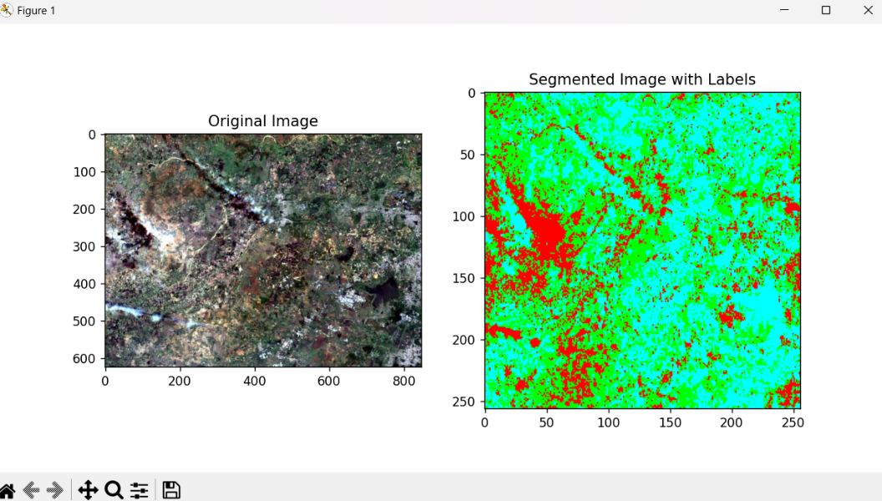

**Fig. 3.** Red – Polluted water, Green – Agricultural Land, Blue – Non-Polluted Water

1. Conclusion

The detection of agricultural runoff into waterbodies using Digital Image Processing (DIP) techniques proves to be a highly effective approach for monitoring and managing the environmental impact of agricultural practices. This study utilized remote sensing data, spectral analysis, and advanced image processing methods to successfully identify areas affected by runoff, quantify pollutant loads, and assess changes in water quality over time. The NDVI and NDWI indices provided clear differentiation between vegetation, soil, and water, enabling accurate detection of runoff areas. Spectral signature analysis was particularly useful in identifying specific pollutants such as nitrates and phosphates within the runoff, which is crucial for pinpointing sources of contamination and assessing their environmental impact. Temporal analysis revealed significant seasonal variations in runoff patterns, correlating with periods of intense agricultural activity and rainfall events, offering valuable insights for understanding the dynamics of runoff and planning timely interventions. Classification techniques like clustering and thresholding effectively segmented land cover types, though challenges remained in areas with mixed land use patterns. Overall, this methodology demonstrated a comprehensive and robust approach to monitoring agricultural runoff, providing essential information for the development of targeted mitigation strategies to protect water quality. Future work should focus on enhancing classification accuracy, particularly in complex land use areas, and improving the temporal resolution of data to better capture short-term runoff events.

References

1. Rouse, J. W., Haas, R. H., Schell, J. A., & Deering, D. W. (1974). Monitoring Vegetation Systems in the Great Plains with ERTS. NASA Special Publication, 351, 309.

Gao, B. C. (1996). NDWI—A normalized difference water index for remote sensing of vegetation liquid water from space. Remote Sensing of Environment, 58(3), 257-266.

2. Jensen, J. R. (2005). Introductory Digital Image Processing: A Remote Sensing Perspective (3rd ed.). Pearson Prentice Hall.

Curran, P. J. (1989). Remote sensing of foliar chemistry. Remote Sensing of Environment, 30(3), 271-278.

3. Singh, A. (1989). Review Article Digital change detection techniques using remotely-sensed data. International Journal of Remote Sensing, 10(6), 989-1003.

Coppin, P., & Bauer, M. E. (1996). Digital change detection in forest ecosystems with remote sensing imagery. Remote Sensing Reviews, 13(3-4), 207-234.

4. MacQueen, J. (1967). Some methods for classification and analysis of multivariate observations. Proceedings of the Fifth Berkeley Symposium on Mathematical Statistics and Probability, Volume 1: Statistics, 281-297.

Otsu, N. (1979). A Threshold Selection Method from Gray-Level Histograms. IEEE Transactions on Systems, Man, and Cybernetics, 9(1), 62-66.

5. Vandenberghe, V., Bauwens, W., & Vanrolleghem, P. A. (2007). Evaluation of uncertainty propagation into river water quality predictions to guide future monitoring campaigns. Environmental Modelling & Software, 22(5), 725-732.

Johnes, P. J. (1996). Evaluation and management of the impact of land use change on the nitrogen and phosphorus load delivered to surface waters: The export coefficient modelling approach. Journal of Hydrology, 183(3-4), 323-349.

6. Beven, K. J., & Kirkby, M. J. (1979). A physically based, variable contributing area model of basin hydrology. Hydrological Sciences Journal, 24(1), 43-69.

Arnold, J. G., & Fohrer, N. (2005). SWAT2000: Current capabilities and research opportunities in applied watershed modelling. Hydrological Processes, 19(3), 563-572.

7. Gonzalez, R. C., & Woods, R. E. (2018). Digital Image Processing (4th ed.). Pearson.

Sonka, M., Hlavac, V., & Boyle, R. (2014). Image Processing, Analysis, and Machine Vision (4th ed.). Cengage Learning.

8. Lillesand, T. M., Kiefer, R. W., & Chipman, J. (2014). Remote Sensing and Image Interpretation (7th ed.). Wiley.

Campbell, J. B., & Wynne, R. H. (2011). Introduction to Remote Sensing (5th ed.). Guilford Press.